Potential Energy
Potential energy is stored energy.
Food has potential energy stored in the chemicals it is made up of.
A stretched elastic band has potential energy called elastic potential energy.
An object positioned above the ground has gravitational potential energy.
Complete this table.
Situation | Type of potential energy(gravitational, elastic or chemical)
Wood used as fuel in a fire

An apple in a tree

A stretched spring

Petrol as a fuel used in a car

We can calculate the gravitational potential energy of an object.
Gravitational potential energy= Mass(kg) x 9.8 x Height (m)
E_{p} = MGH
G=9.8. This is the gravitational constant for Earth. We need to use this as the gravitational force can change if we leave Earth.
Bob has a mass of 90Kg. He is standing 2m above the ground. What is his gravitational potential energy?
E_{p} = MGH
=90 x 9.8 x 2
1764j or 1.764kj

- A model glider has a mass of 1 kg. How much potential energy does it have 2 meters off the ground?

- An aeroplane has a mass of 4,90kg. If it is 1,000 meters off the ground, how much potential energy does it have?

- An orange has a mass of 0.5kg. It is 1.5m of the ground. What is its potential energy?

- 2kg brick is 200m of the ground. What is its potential energy?

- A bird has a mass of 400g. It is sitting on a roof top 10m of the ground. How much potential energy does this bird have?

Measuring your potential energy!
You will be calculating the potential energy you have when standing on your desk.
Step one: Measure the height of your desk.
Step two: Measure your mass using the scales.
Potential energy = objects mass x gravity x height or E_{p} = mgh

= _____kg x 9.8 x ______m
Your potential energy in joules ____________ j
Divide by 1000.
Your potential energy in Kj _______________ kj

Kinetic and Potential Energy
Kinetic and potential energy . Write the definition for each below.

Kinetic energy=

Potential energy=

Look at this diagram and use it to complete the table below it.
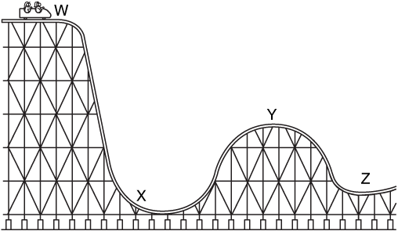

Position | Type of Energy
W
X
Y
Z

